**1.PROBLEM**

**CSS with Images**

David is a web designer at Together Studios, which specializes in offering the best photography services with the blend of the right acumen, adroitness and equipment backed with our strategic associations. David takes care of the website, blogs of the studio and has to upload a recent photo shoot at a celebrity wedding.  
  
He chose a sample picture of the wedding and tried the 'black and white' effect, but was unable to bring out the effects on the image. Let us help him to create a grayscale effect on the image using filter property in CSS.

**Hints :**

**filter property**

The filter property defines visual effects (like blur and saturation) to an element (often <img>).

**grayscale**

Converts the image to grayscale. 0% (0) is default and represents the original image.

100% will make the image completely gray (used for black and white images).

Syntax :

filter: none | blur( ) | brightness( ) | contrast( ) | drop-shadow( ) | grayscale( ) | hue-rotate( ) | invert( ) | opacity( ) | saturate( ) | sepia( ) | url( );

**Content :**  
h1 - Wedding Album  
**img** src attribute =**"wedding.jpg"**  
  
**Constraints :**  
The count of an img tag should be 2.  
The first image should not have any effects.  
The second image should have a grayscale filter applied to it.  
**filter : grayscale(100%)**  
  
**Note :**  
Web page should be displayed as shown in the screenshot.  
Kindly refer the content which is given as a part of the description.  
  
**Sample Screenshot 1 :**  
  
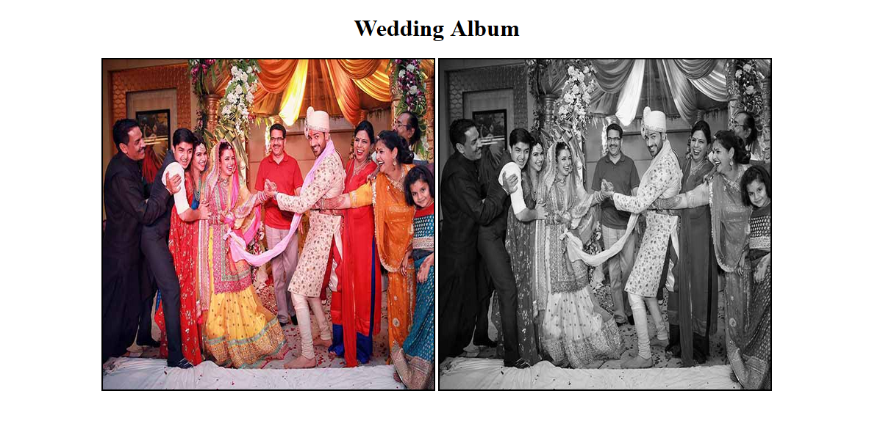  
  
**Sample Screenshot 2 :**  
  
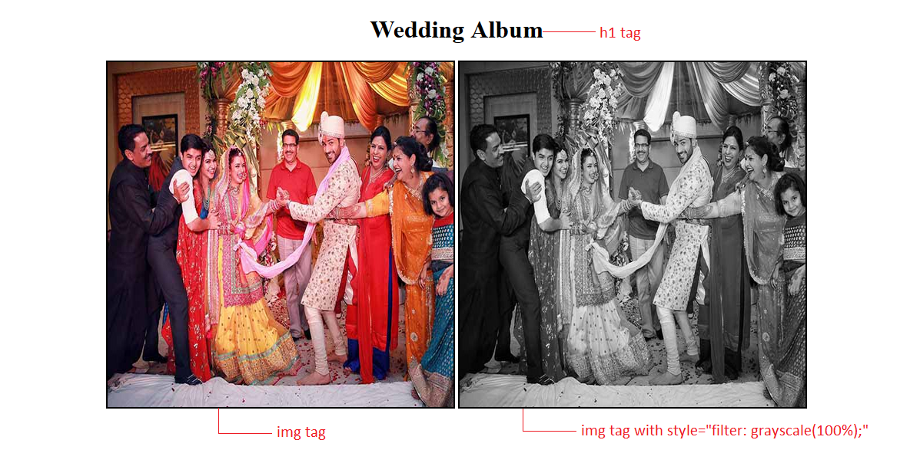

**2.PROBLEM**

**Media Types - video autoplay**

Being the Marketing Head, Harsha wants to promote their company "Global Organizers" amongst the corporate. As per his instructions, the creative team has created a promotion video of all the Events recently organized by theme. The promotion video should have auto play options to captivate its viewers. Hence the creative team has requested you to create a web page containing a video clip using the video tag with autoplay attribute.

**Hints :**

**Tag video**

 The <video> tag specifies video, such as a movie clip or other video streams.

**autoplay attribute**

The autoplay attribute is a boolean attribute. When present, the video will automatically start playing as soon as it can do so without stopping.

Syntax :

<video autoplay>

 <source src="xxx.ogg" type="video/ogg">

 <source src="xxx.mp4" type="video/mp4">

</video>

**Constraints :**  
The file name should be index.html  
Design the html page as given in the screenshot1.  
The source attribute must be present in the same order as mentioned in the hint.  
Refer the screenshot for html specifications.  
  
**Note :**  
The web page  should be displayed as shown in the screenshot.  
The video file is given as a part of template.  
  
**Sample Screenshot 1 :**

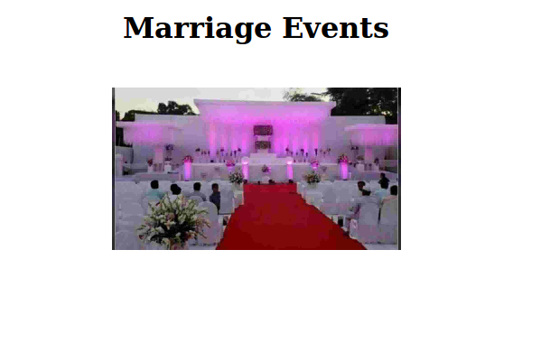  
  
**Sample Screenshot 2 :**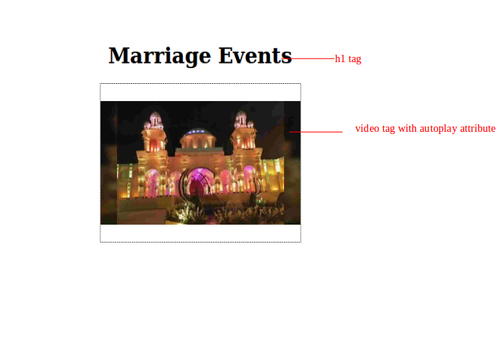  
  
**Sample Screenshot 3 :**  
  
 